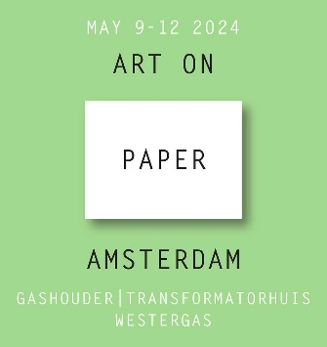

PRESS RELEASE April 2024

ART ON PAPER AMSTERDAM
Exhibition GREEN PAPER – Association of Corporate Collections Netherlands (VBCN)

From Thursday, May 9 to Sunday, May 12, 2024, the 4th edition of the art fair Art on Paper Amsterdam will be organized at Westergas. In the Gashouder, both young and established galleries will exhibit contemporary works of exceptional talent on, of, or with paper. In the Transformatorhuis, renowned art dealers will present – for the first time this year – art on paper ranging from masters to twentieth-century artists.

Art on Paper Amsterdam has the tradition of inviting private and corporate collections to showcase their works on paper in the central exhibition at the fair. Therefore, this year, the Association of Corporate Collections Netherlands (VBCN) will exhibit works on paper from the collections of its members, many of which have been acquired from participating galleries. VBCN is a non-profit network for Dutch companies and (semi)public institutions with an art collection policy.

In the exhibition Green Paper, members of the Association of Corporate Collections Netherlands will showcase artworks by artists reflecting on the theme of sustainability. Artists often anticipate movements that manifest as phenomena in society, and their artworks thus form a Green Paper avant la lettre. Some focus on material circularity, with everyday objects and packaging infiltrating their artistic practice. Others delve into cultural diversity and inclusion, exploring how power dynamics between humans, nature, and systems can be balanced.

The participating members of the VBCN in the exhibition are: AkzoNobel, Amsterdam UMC, a.s.r., ING, Isala, KPMG, Lakeside Capital Partners, LUMC, Ministry of Foreign Affairs, NN Group, Province of Gelderland, Rabobank, Triodos, and TwynstraGudde. In total, approximately 70 works on paper have been collected for the Green Paper exhibition.

Art on Paper Amsterdam May 9-12, 2024
Location: Gashouder and Transformatorhuis (Westergas), Klönneplein 1 en 2, 1014 DD Amsterdam
Opening hours: May 9 2024 from 6.00 pm - 9.00 pm (opening), May 10-12 11.00 am - 7.00 pm

